**Big Sprites**

Big Sprite ROMS are in CC02 and CC01 chips (each are 2048 bytes). These are arranged as 256 graphic characters with each character being 8x8 pixels (realized by 8 bytes per character). There are two ROMs per character set, so each of the 256 characters x 8 bytes per character have two bits for color. This gives 4096 bytes per character set.

Here is the bigsprite graphics set. Note that I used the default palette values for each bigsprite. The top left value is character $00. There are 32 characters across and 8 down for a total of 256. The left row character values are (from top to bottom) $00, $20, $40, $60, $80, $A0, $C0, and $E0.

The helicopter is located in rows 1-4, columns 1-16.

The bird is located in rows 1-4, columns 16-32.

The balloon is located in rows 5-6, columns 1-12.

The building door names are located in rows 7-8, columns 1-8.

The "Crazy Climber title graphics are located in rows 5-6, columns 13-22 *and* rows 7-8, columns 8-22.

The falling sign is located in rows 5-8, columns 27-32.

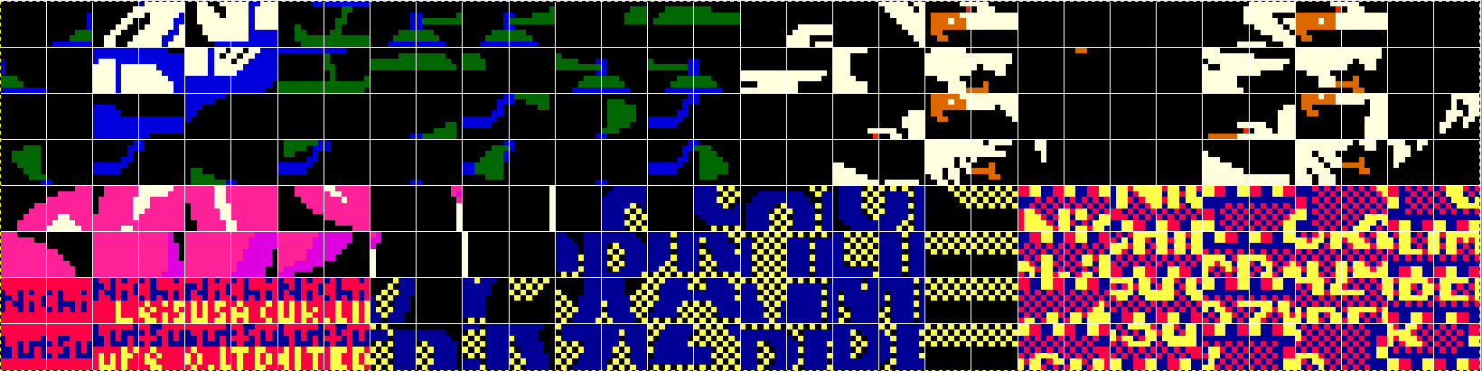

Big sprites are set up by writing to the big sprite RAM $8800 - $88FF). There are 256 bytes of big sprite RAM area, arranged as a grid of 16 bytes per row with 16 rows. The big sprites are constructed here by writing a character value of $0 - $FF within this memory area. These character values correspond to the 256 available graphic characters within CC02 and CC01.

Big sprites are controlled by memory locations $98DC - $98DF and are described below:

$98DC (Offset 0) - ???

Priority?

$98DD (Offset 1) - Color, inversion

Bits 7, 6 are unused

Bit 5 is the Y invert (flips the big sprite top/bottom)

Bit 4 is the X invert (flips the big sprite left/right)

Bit 3 ??

Bit 2-0: color index (0 is palette offset 16, 7 is palette offset 23)

$98DE (Offset 2) - Y Screen Position

$98DF (Offset 3) - X Screen Position

**Palette**

The palette for crazy climber is shown below:

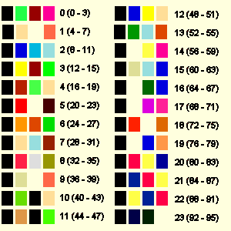

Big Sprite Color Selection

The big sprite color palette selections start at index 16 and go through index 23. These are selected by bits 2-0 of the big sprite control ($98DD). A value of 0 corresponds to set 16, and a value of 7 corresponds to set 23.

**Helicopter**

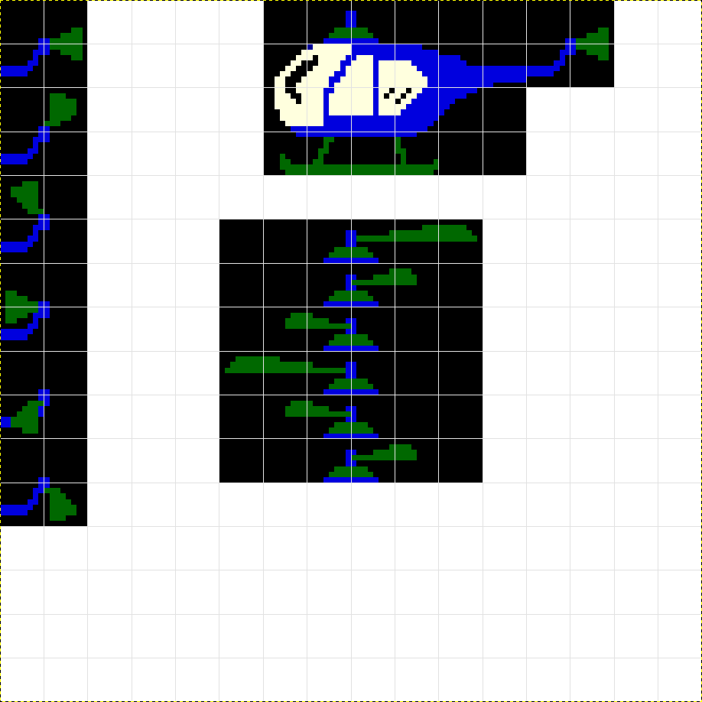

48 49 00 01 20 21 40 41 48 49

4A 4B 02 03 22 23 42 43 4A 4B

4C 4D 04 05 24 25 44 45

4E 4F 06 07 26 27 46 47

60 61 Helicopter Body Data at $2E28 (actual draw location above)

62 63 00 00 08 09 28 29 Position 1

64 65 00 00 0A 0B 2A 2B Position 2

66 67 0C 0D 2C 2D 00 00 Position 3

68 69 0E 0F 2E 2F 00 00 Position 4

6A 6B 0C 0D 2C 2D 00 00 Position 5

6C 6D 00 00 0A 0B 2A 2B Position 6

6E 6F Top Blade data at $2DFE

Tail Section data at $2E22

The helicopter is drawn in parts. $2C1A is where the ISR jumps to check on the helicopter. The body of the helicopter is drawn at $2C74, using character data from $2E28. It is drawn in a 2x2 manner, calling the 2x2 draw routine at $354F. The bottom half is drawn first, writing to bigsprite RAM $88E6, $88E8, $88EA for each 2x2 call, then drawing the top half by writing to $88C6, $88C8, and $88CA.

The helicopter top and tail blades are animated by calling the $2D9E routine. The top blade is animated by writing 5 characters to $88C5 - $88C9. The top blade data is located at $2DFE.

The tail blade is animated by writing a 2x2 character block with $88CC for the bigsprite RAM destination for the 2x2 call. The tail blade data is located at $2E22.

The helicopter color is 0, which corresponds to the palette index 16: 

Helicopter movement is handled by the routine at $2CF8. The X and Y positions are updated using the bigsprite control. The direction of the helicopter is changed by setting or clearing bit 4 of $98DD (x invert).

**Balloon**

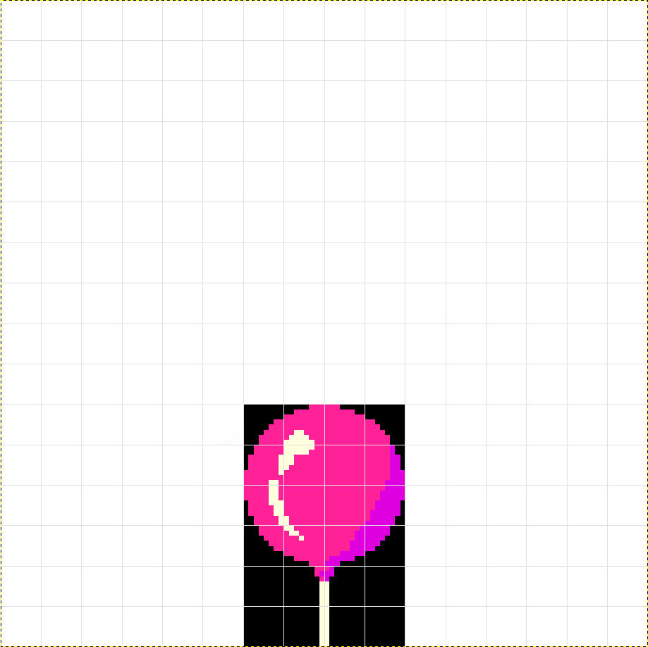

Bigsprite RAM space, starting at $8800

$8810

$8820

$8830

$8840

$8850

$8860

$8870

$8880

$8890

$88A0 80 81 A0 A1 Top data at $3F94

$88B0 82 83 A2 A3

$88C0 84 85 A4 A5 Middle data at $3F92

$88D0 86 87 A6 A7

$88E0 88 89 A8 A9 Bottom data at $3F90

$88F0 8A 8B AA AB

$38DB is where the ISR jumps to check on the balloon. The balloon is drawn at $3E01 and is broken into 4 parts: Initialization ($3910), top ($3968), middle ($3946), and the bottom string ($3932).

The balloon top data is located at $3F94 and is drawn in a 2x2 manner, calling the 2x2 draw routine at $354F. This is written to bigsprite RAM $88A6 and $88A8. The middle data is located at $3F92 and written to bigsprite RAM at $88C6 and $88C8 in 2x2 calls. The bottom data is located at $3F90 and written to bigsprite RAM at $88E6 and $88E8 in 2x2 calls.

The balloon color is 1, which corresponds to the palette index 17: 

Balloon movement is handled by the routine at $39AA?. The X and Y positions are updated using the bigsprite control.

**Evil Bird**

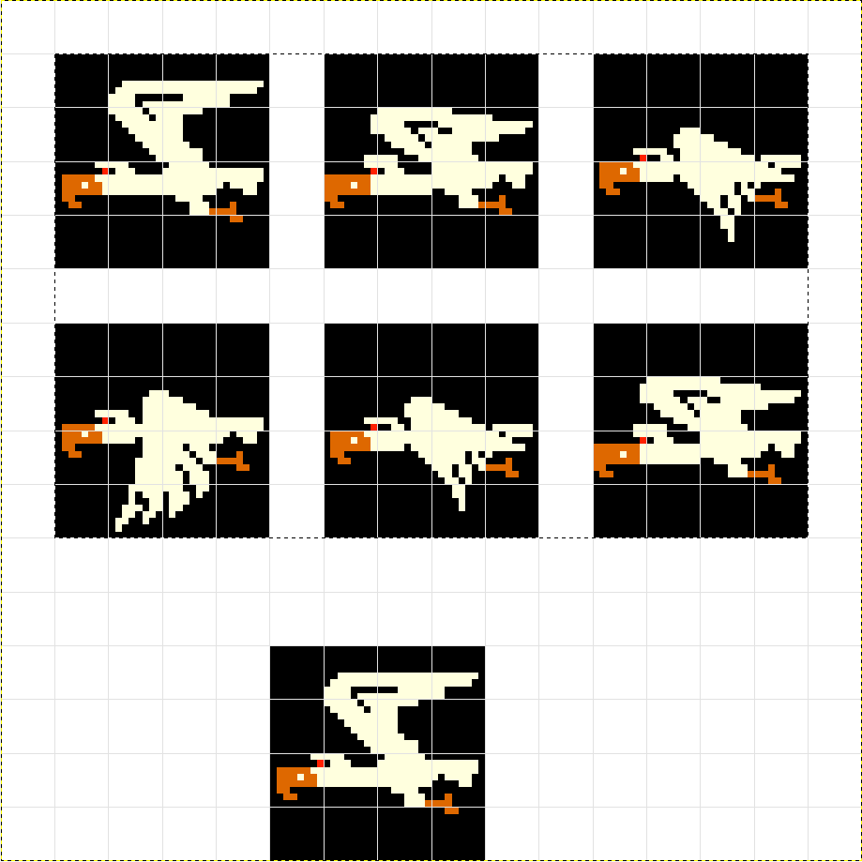

Bigsprite RAM space, starting at $8800

$8810 10 11 31 32 18 19 38 39 50 51 70 71

$8820 12 13 33 34 1A 1B 3A 3B 52 53 72 73

$8830 14 15 35 36 1C 1D 3C 3D 54 55 74 75

$8840 16 17 37 38 1E 1F 3E 3F 56 57 76 77

$8850 Animation 0 Animation 1 Animation 2

$8860 58 59 78 79 50 51 70 71 58 59 78 79

$8870 5A 5B 7A 7B 52 53 72 73 58 59 78 79

$8880 5C 5D 7C 7D 54 55 74 75 58 59 78 79

$8890 5E 5F 7E 7F 56 57 76 77 58 59 78 79

$88A0 Animation 3 Animation 4 Animation 5

$88B0 Actual Bigsprite Draw Location

$88C0 10 11 30 31

$88D0 12 13 32 33

$88E0 14 15 34 35

$88F0 16 17 36 37

$339A is where the ISR jumps to check on the evil bird. The bird is drawn at $33E0. The bigsprite priority? is set to 0, the initial Y position is set to $F0, the initial X position is set to $F0, and the color/attribute byte is set to $02. This corresponds to the palette index 18: 

If the bird needs to face right (instead of the default graphic left), the color/attribute byte is set to $12 (invert X-axis) and the initial X position is set to $90. One more wrinkle - if the field is inverted, the initial Y position is $F0 + $20, or $10.

The Bird data is located at $3562 and is drawn in a 2x2 manner, calling the 2x2 draw routine at $354F. This is written to bigsprite RAM $88C6, $88C8, $88E6, and $88E8 with successive 2x2 draws. Each bird draw is a group of 4 data values.

The bird is animated and has 6 animation sequences. Each bird draw uses 4 data values, so there are 24 data values for the bird at $3562. The animation code is located at $3504.

Bird movement is handled by two routines - one at $3445 and another at $34BA. The X and Y positions are updated using the bigsprite control, along with the bird direction through the X-axis invert bit.

The bird poop routine is found $35EA. It handles checking if it is time for the bird to poop as well as the bird poop movement <rimshot>.

**Falling Sign**

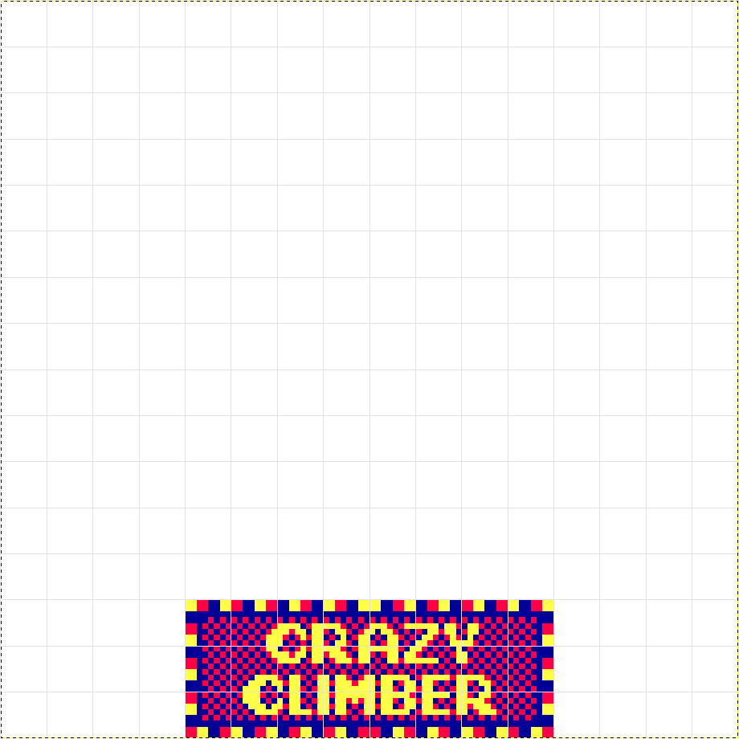

Bigsprite RAM space, starting at $8800

$8810

$8820

$8830

$8840

$8850

$8860

$8870

$8880

$8890

$88A0

$88B0

$88C0

$88D0 9A 9B BA BB DA DB FA FB

$88E0 9C 9D BC BD DC DD FC FD

$88F0 9E 9F BE BF DE DF FE FF

$3E04 is where the ISR jumps to check on the falling sign. The sign is drawn at $3EEB. The bigsprite priority? is set to 1, the initial Y position is set to $F0, the initial X position is a random number that is 0, 16, 32, 48, 64, 80, 96, or 112. I can't see where the color/attribute is set, but in the MAME debug the value is $05. This corresponds to the palette index 21: 

The falling sign data is located at $3F96 and is drawn in a 2x2 manner, calling the 2x2 draw routine at $354F. This is written to bigsprite RAM $88E4, $88E6, $88E8, and $88EA with successive 2x2 draws. This continues again by writing 2x2 draws to $88D4, $88D6, $88D8, and $88DA. Note that this actually overwrites some of the data written in the first group, making a sign that is 3 characters high.

**Electric Sign**

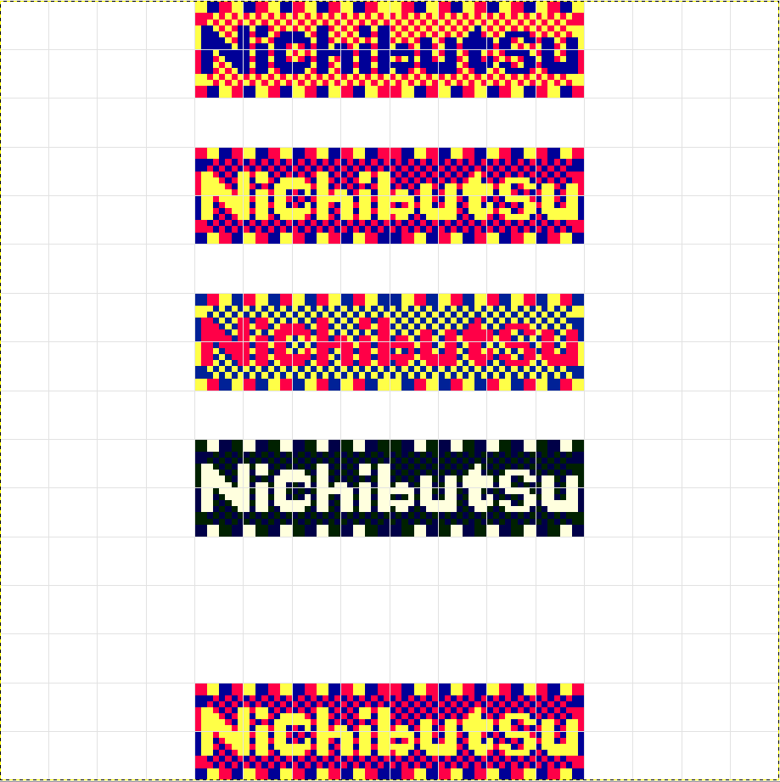

$8810 Bigsprite RAM Palette 20 (4)

$8810

$8820

$8830 Palette 21 (5)

$8840

$8850

$8860 Palette 22 (6)

$8870

$8880

$8890 Palette 23 (7)

$88A0

$88B0

$88C0

$88D0 Location of bigsprite RAM for the final sign

$88E0 96 97 B6 B7 D6 D7 F6 F7

$88F0 98 99 B8 B9 D8 D9 F8 F9

$3B66 is where the ISR jumps to check on the electrified sign. The sign is drawn at $3B75. The bigsprite priority? is set to 1, the initial Y position is set to $F0, the initial X position is $28 for building 1 or 2, and $30 for building 3 or 4. The color/attribute is set as $05 (normal) or $15 if the field is inverted (X invert). This corresponds to palette index 21: 

The electric sign data is located at $3FAE and is drawn in a 2x2 manner, calling the 2x2 draw routine at $354F. This is written to bigsprite RAM $88E4, $88E6, $88E8, and $88EA with successive 2x2 draws.

The palette is changed to make the "lights" change on the sign. It changes from 4 - 7.

**Title Graphics**

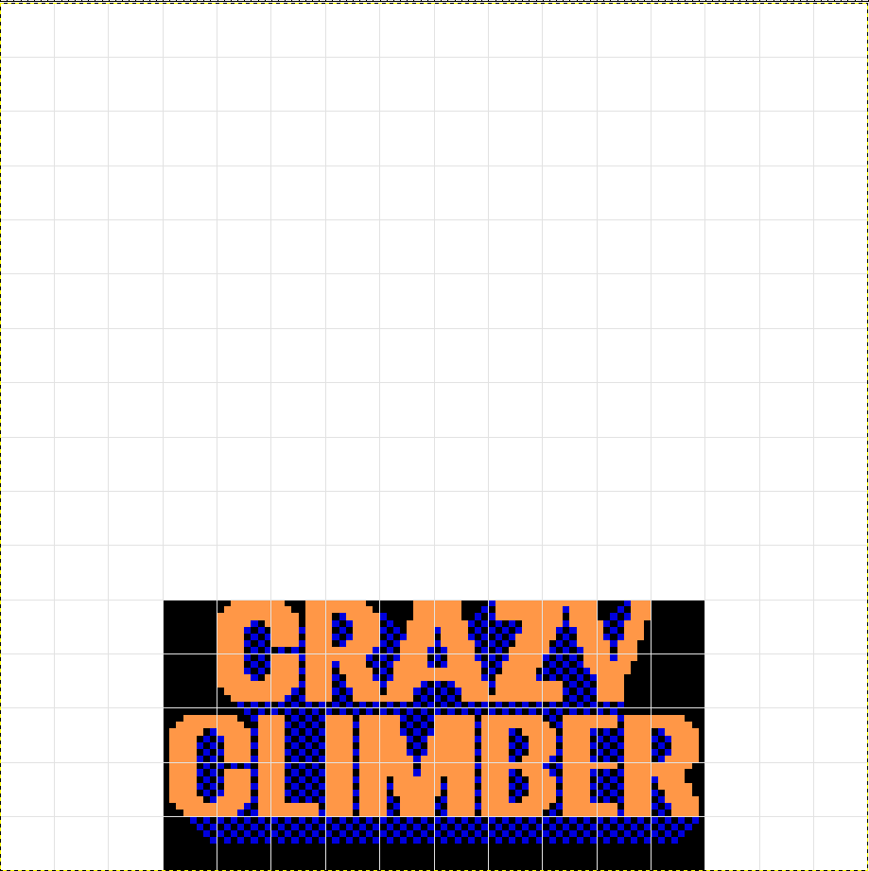

Bigsprite RAM space, starting at $8800

$8810

$8820

$8830

$8840

$8850

$8860

$8870

$8880

$8890

$88A0

$88B0 8C 8D AC AD CC CD EC ED C8 C9

$88C0 8E 8F AE AF CE CF EE EF CA C9

$88D0 90 91 B0 B1 D0 D1 F0 F1 F5 CB

$88E0 92 93 B2 B3 D2 D3 F2 F3 F5 CB

$88F0 94 95 B4 B5 D4 D5 F4 F5 F5 CB

$0948 is the routine where the title graphics are drawn. The bigsprite priority? is set to 4, the initial Y position is set to $F0, the initial X position is $40. The color/attribute is set to 3. This corresponds to the palette index 19: 

The title graphic data is located at $09C4. It is arranged with 10 bytes per row, starting from the bottom up. The bigsprite RAM location for each draw row starts at $88F3, then draws $88E3, then $88D3, then $88C3. The bigsprite is then scrolled down the screen by decrementing the Y position until it reaches $E0. Once it reaches this value, the top line of graphic data located at $09EC is loaded to bigsprite RAM at $88B3. It continues to scroll down until Y = $91. Now the graphics scroll up by increasing Y.